Lab 4 Tilt Switch Sensor

Introduction
The tilt switch sensor module is a ball tilt switch with a metal ball inside. It is used to detect inclinations of a small angle.

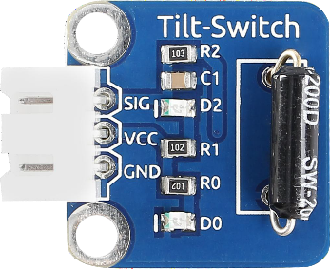

Components
- 1 * Arduino Uno board
- 1 * USB data cable
- 1 * Tilt switch module
- Several jumper wires

Experimental Principle
The principle is very simple. When the switch is tilted in a certain angle, the ball inside rolls down and touches the two contacts connected to the pins outside, thus triggering circuits. Otherwise the ball will stay away from the contacts, thus breaking the circuits.
In this experiment, we use a tilt switch module and an LED that has been attached to pin 13 of the SunFounder board to build a simple circuit. With the LED attached to pin 13, connect pin SIG to digital pin 7 of the SunFounder Uno board. Then the tilt switch outputs low signals and the LED will be on. Otherwise it will be off.

Experimental Procedures
Step 1: Build the circuit
Step 2: Program
Step 3: Compile
Step 4: Select the correct board and port
Step 4: Upload the sketch to Arduino U

Now, tilt the switch and the LED attached to pin 13 on SunFounder Uno board will
light up.

A) Design and implement
Hardware implementation with the Arduino board and the bread board
B) Program
const int sigPin = 7; // the number of the tilt switch pin
const int ledPin = 13; // the number of the LED pin
//variables
boolean sigState = 0; // variable for reading the tilt switch status

void setup()
{
// initialize the LED pin as an output:
pinMode(ledPin, OUTPUT);
// initialize the tilt switch pin as an input:
pinMode(sigPin, INPUT);
Serial.begin(9600);
}

void loop()
{
// read the state of the tilt switch value:
sigState = digitalRead(sigPin);
Serial.println(sigState);

if (sigState == HIGH)
{
// turn LED off:
digitalWrite(ledPin, LOW);
}
else
{
// turn LED on:
digitalWrite(ledPin, HIGH);
}
}

C) Test
- Test theHardware implementation with the arduino uno board
- Change the program as below
Original program your program to be modified
Baudrate 9600 4800
Serial display variable: sigState sigState
text “It is tilted!” if sigState==0
Deliverables
Give a demo to TA to show the revised program is working properly.
Discuss the definition of Baudrate within the group
Discuss the behavior of the capacitor in the DC circuit of this tilt switch module
Submit the revised code online along with a picture of your circuit.

